Following are the challenges faced

1. Usage of docker due to increase in number of scripts due to performance issues
2. Reading of pdf: Give an example.
3. Test Flakiness : as described in below image

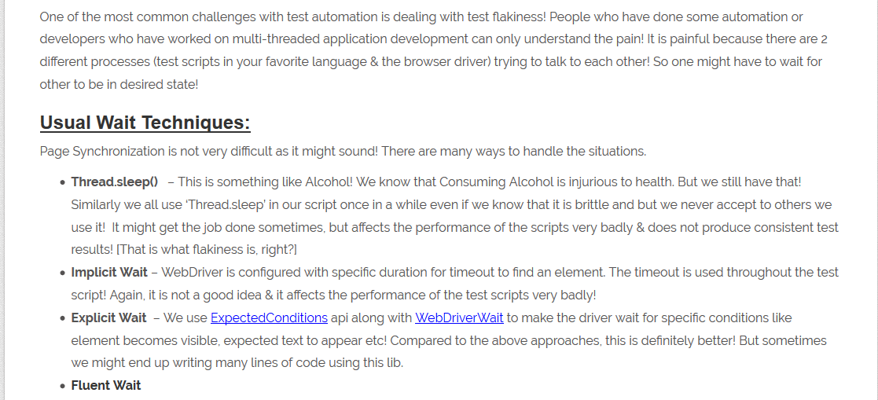

To overcome above synchronization issue, we had used ‘Awaitility’ library

